**EXPERIMENT-1**

**Submitted by:**   
Ajay Kumar Tyagi  
500067403  
R171218008  
CSE-DevOps 2018-2022

**Aim-** Installation and execution of Vagrant and configuration of Docker and starting its container in vagrant.

**Procedure:**

**1)** Download vagrant from the website of Hashi Corp and install it in your system.

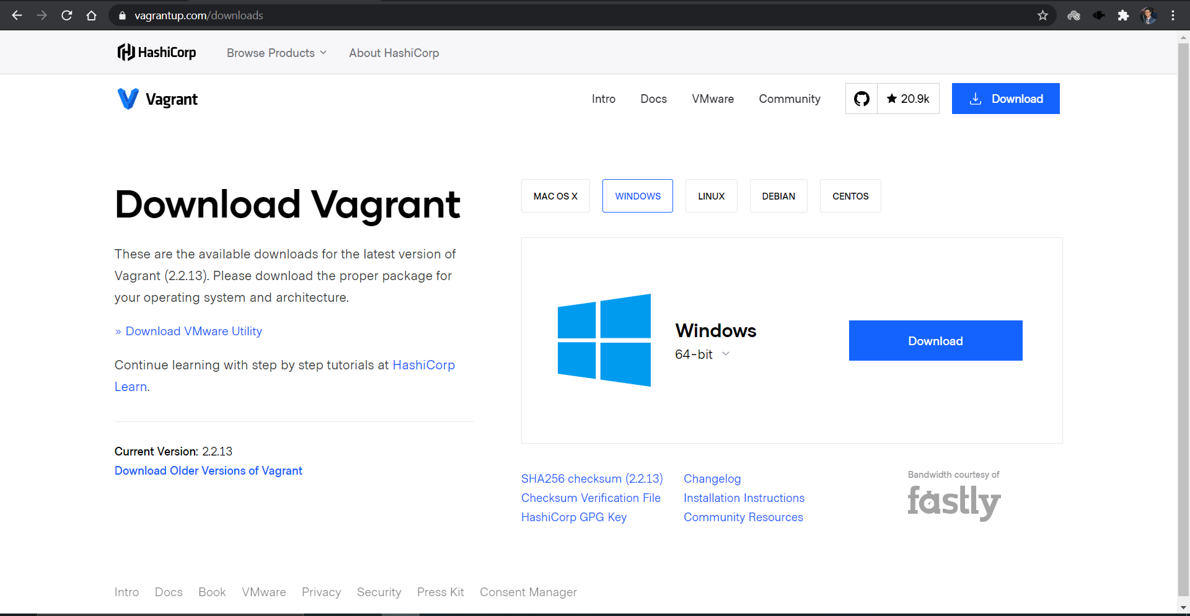

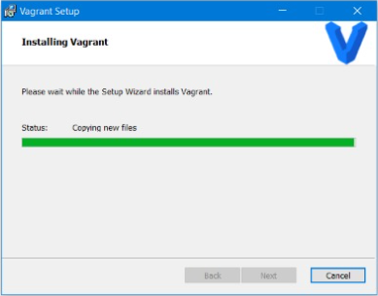

**2)** Now create a directory for workspace and to initialize use command vagrant init.

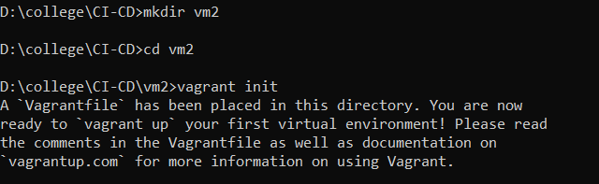

**3)** After initializing the vagrant successfully, vagrant file will be created in our workspace. We have to configure the vagrant file so that vagrant can create virtual machine. For this we set config.vm.box= ”Ubuntu/xenial64”.

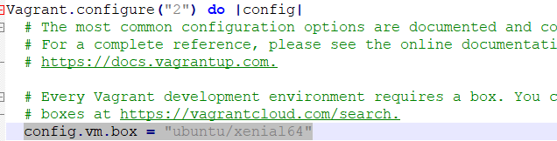

**4)** After successfully configuring the vagrant file, in command line run vagrant up command. This command will download Ubuntu and will create a virtual machine.

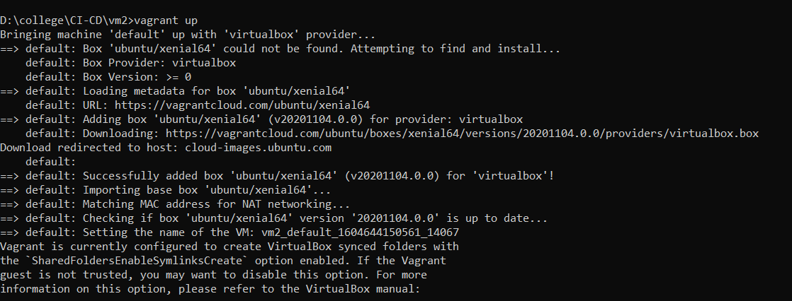

**5)** Now run the vagrant ssh command to attach the virtual machine to your windows command line. Now we can operate the virtual machine from windows command line.

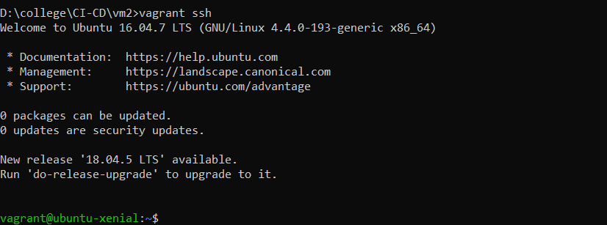

**6)** We have to attach vagrant virtual machine and add GPG key for the official docker repository to your Ubuntu-xenial as shown below.

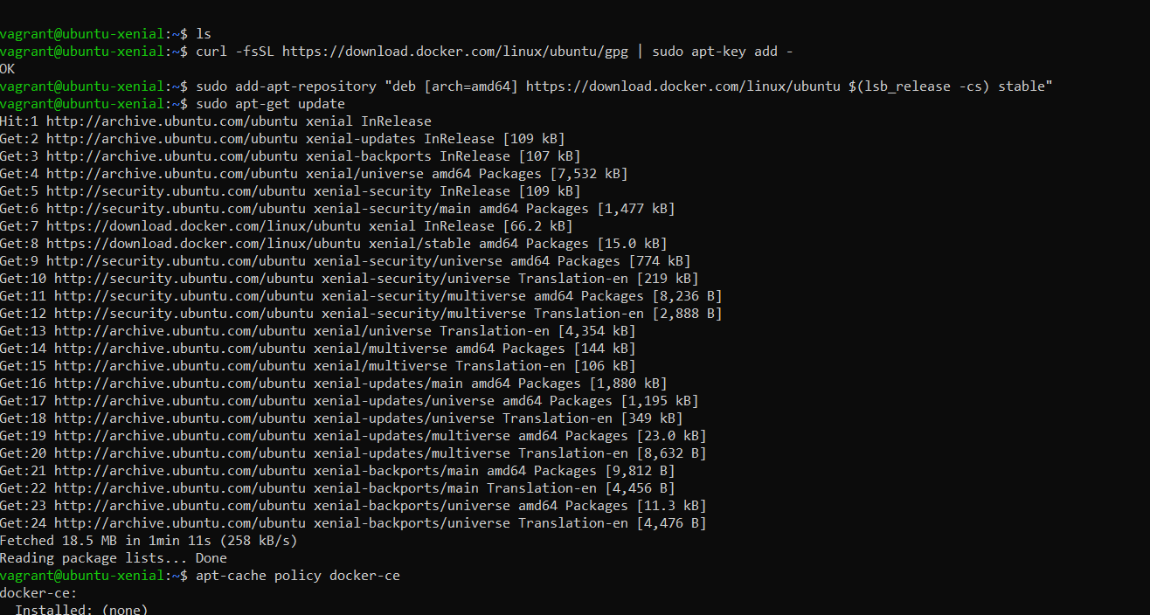

**7)** Use command apt-cache policy docker-ce to add docker repository to APT resources.

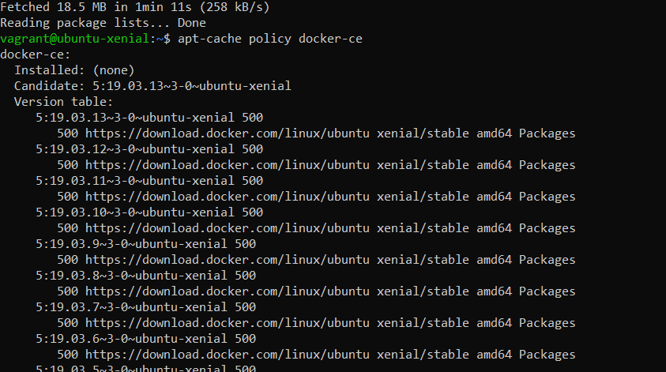

**8)** Now update the package database with the docker packages from the recently added repository and then update the policy. After this install the docker with sudo apt-get install –y docker-ce.

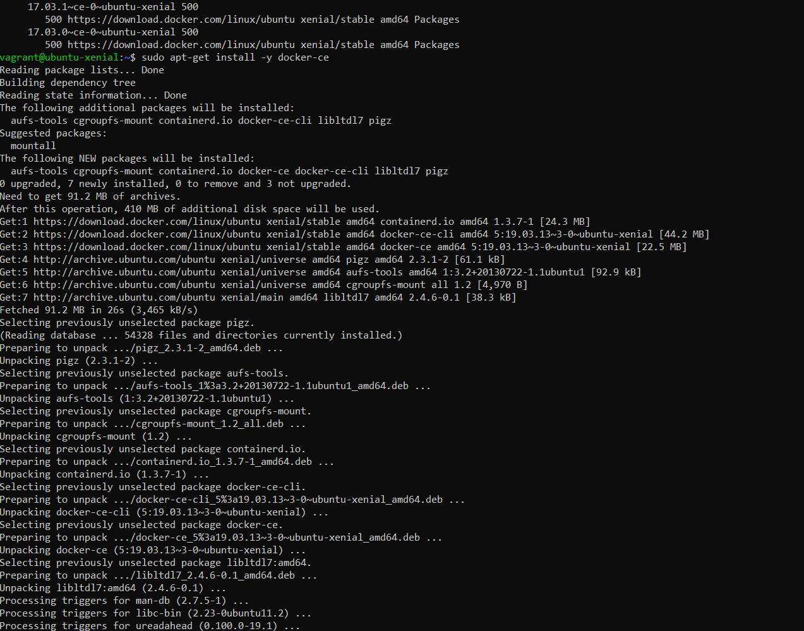

**9)** To verify if docker is configured, use command systemctl status docker.

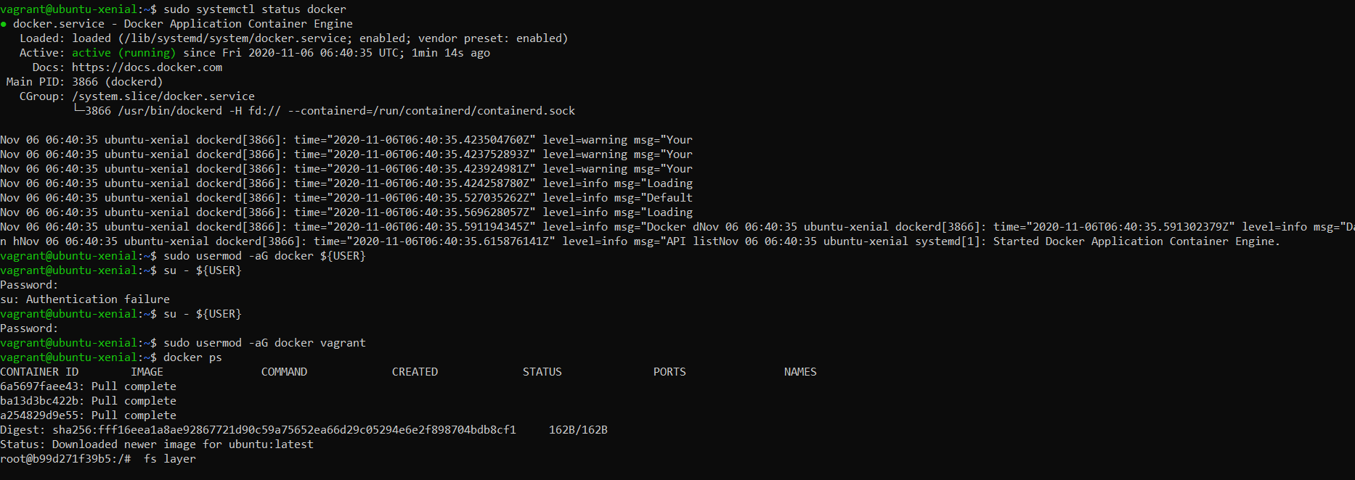

**10)** Now create a user for docker and add this user to vagrant group.



**11)** Use command docker run –it Ubuntu to create a container of Ubuntu image. This command will automatically fetch Ubuntu image from docker hub.

